9 de diciembre de 2022

Estimados amigos:

A través de este nuevo boletín informativo, os hacemos llegar las últimas novedades del **Clúster 3: Seguridad civil para la sociedad**

* **Convocatoria 2022 Clúster 3: estadística de propuestas presentadas**

Las 6 convocatorias de 2022 correspondientes al Clúster 3 “Seguridad civil para la sociedad” cerraron los pasados días 16 de noviembre (convocatoria CS) y el 23 de noviembre (resto de convocatorias).

A continuación, os incluimos un detalle sobre el número de propuestas presentadas por topic para estas convocatorias:

***Submissions to call HORIZON-CL3-2022-CS-01: A total of 125 proposals has been submitted to call HORIZON-CL3-2022-CS-01, which closed on 16 November 2022****. These proposals, of which the evaluation will be organized over the coming weeks and months, were submitted to the following topics:*

* ***HORIZON-CL3-2022-CS-01-01*** *- Improved monitoring of threats, intrusion detection and response in complex and heterogeneous digital systems and infrastructures (IA) -* ***62 proposals***
* ***HORIZON-CL3-2022-CS-01-02*** *- Trustworthy methodologies, tools and data security “by design” for dynamic testing of potentially vulnerable, insecure hardware and software components (RIA) -* ***42 proposals***
* ***HORIZON-CL3-2022-CS-01-03*** *– Transition towards Quantum-Resistant Cryptography (IA) –* ***11 proposals***
* ***HORIZON-CL3-2022-CS-01-04*** *- Development and validation of processes and tools used for agile certification of ICT products, ICT services and ICT processes (IA) –* ***10 proposals***

***Submissions to call HORIZON-CL3-2022-FCT-01:******A total of 41 proposals have been submitted in response to this call.*** *The number of proposals for each topic is shown below including the indicative budget of the topics for 2022:*

* + ***HORIZON-CL3-2022-FCT-01-01:*** *1 proposal (indicative budget: 7 M€)*
  + ***HORIZON-CL3-2022-FCT-01-02:*** *2 proposals (indicative budget: 3 M€)*
  + ***HORIZON-CL3-2022-FCT-01-03:*** *13 proposals (indicative budget: 3 M€)*
  + ***HORIZON-CL3-2022-FCT-01-04:*** *6 proposals (indicative budget: 3 M€)*
  + ***HORIZON-CL3-2022-FCT-01-05:*** *6 proposals (indicative budget: 15 M€ shared with FCT-01-06 and FCT-01-07)*
  + ***HORIZON-CL3-2022-FCT-01-06****: 5 proposals (indicative budget: 15 M€ shared with FCT-01-05 and FCT-01-07)*
  + ***HORIZON-CL3-2022-FCT-01-07:*** *8 proposals (indicative budget: 15 M€ shared with FCT-01-05 and FCT-01-06)*

***Submissions to call HORIZON-CL3-2022-DRS-01:******A total of 126 proposals have been submitted in response to this call.*** *The number of proposals for each topic is shown below including the indicative budget of the topics for 2022:*

* + ***HORIZON-CL3-2022-DRS-01-01:*** *26 proposals (indicative budget: 10 M€ shared with DRS-01-03)*
  + ***HORIZON-CL3-2022-DRS-01-02:*** *25 proposals (indicative budget: 10 M€ shared with DRS-01-04)*
  + ***HORIZON-CL3-2022-DRS-01-03:*** *0 proposals (indicative budget: 10 M€ shared with DRS-01-01)*
  + ***HORIZON-CL3-2022-DRS-01-04****: 26 proposals (indicative budget: 10 M€ shared with DRS-01-02)*
  + ***HORIZON-CL3-2022-DRS-01-05:*** *17 proposals (indicative budget: 10 M€ shared with DRS-01-06)*
  + ***HORIZON-CL3-2022-DRS-01-06:*** *3 proposals (indicative budget: 10 M€ shared with DRS-01-05)*
  + ***HORIZON-CL3-2022-DRS-01-07:*** *9 proposals (indicative budget: 5 M€)*
  + ***HORIZON-CL3-2022- DRS-01-08:*** *13 proposals (indicative budget: 11 M€ shared with DRS-01-09)*
  + ***HORIZON-CL3-2022- DRS-01-09:*** *7 proposals (indicative budget: 11 M€ shared with DRS-01-08)*

***Submissions to call HORIZON-CL3-2022-BM-01:******A total of 33 proposals have been submitted in response to this call****. The number of proposals for each topic is shown below including the indicative budget of the topics for 2022:*

* + ***HORIZON-CL3-2022-BM-01-01:*** *15 proposals (indicative budget: 6M€)*
  + ***HORIZON-CL3-2022-BM-01-02:*** *5 proposals (indicative budget: 6M€)*
  + ***HORIZON-CL3-2022-BM-01-03:*** *6 proposals (indicative budget: 6M€)*
  + ***HORIZON-CL3-2022-BM-01-04:*** *3 proposals (indicative budget: 3.5 M€)*
  + ***HORIZON-CL3-2022-BM-01-05:*** *4 proposals (indicative budget: 3.5 M€)*

***Submissions to call HORIZON-CL3-2022-SSRI-01:******A total of 20 proposals have been submitted in response to this call****. The number of proposals for each topic is shown below including the indicative budget of the topics for 2022:*

* + ***HORIZON-CL3-2022-SSRI-01-01:*** *5 proposals (indicative budget: 1.5 M€)*
  + ***HORIZON-CL3-2022- SSRI-01-02:*** *6 proposals (indicative budget: 4 M€)*
  + ***HORIZON-CL3-2022- SSRI-01-03:*** *3 proposals (indicative budget: 2 M€)*
  + ***HORIZON-CL3-2022- SSRI-01-04:*** *6 proposals (indicative budget: 2 M€)*

***Submissions to call HORIZON-CL3-2022-INFRA-01:******A total of 25 proposals have been submitted in response to this call****. The number of proposals for each topic is shown below including the indicative budget of the topics for 2022:*

* + ***HORIZON-CL3-2022-INFRA-01-01:*** *15 proposals (indicative budget: 5 M€)*
  + ***HORIZON-CL3-2022-INFRA-01-02:*** *10 proposals (indicative budget: 6 M€)*

Los resultados de estas convocatorias se conocerán a mediados de abril de 2023.

* **Publicación del Programa de Trabajo 2023-2024 del Clúster 3.**

La Comisión Europea ha publicado esta semana el Programa de Trabajo 2023-2024 del Clúster 3, en el portal del participante**:** [**https://ec.europa.eu/info/funding-tenders/opportunities/docs/2021-2027/horizon/wp-call/2023-2024/wp-6-civil-security-for-society_horizon-2023-2024_en.pdf**](https://ec.europa.eu/info/funding-tenders/opportunities/docs/2021-2027/horizon/wp-call/2023-2024/wp-6-civil-security-for-society_horizon-2023-2024_en.pdf)

Este documentono es definitivo y se le introducirán cambios en el texto antes de la apertura de las convocatorias, previstas para junio de 2023.

* **Consulta pública sobre el Programa Marco (pasado, presente y futuro): del 1 de diciembre de 2022 al 23 de febrero de 2023.**

[**https://ec.europa.eu/eusurvey/runner/Horizon2020HorizonEuropeStrategicPlan2025-2027**](https://ec.europa.eu/eusurvey/runner/Horizon2020HorizonEuropeStrategicPlan2025-2027)

***Consultation period:*** *01 December 2022 - 23 February 2023  (midnight Brussels time)*

*](mailto:Need%20help?%20Please%20contact:%20RTD-PUBLIC-CONSULTATION-HORIZON@ec.europa.eu)*

***Public consultation on the past, present and future of the European Research & Innovation Framework programmes 2014-2027***

***INTRODUCTION***

*This consultation aims to collect the views of research institutions, businesses, consumer organisations, as well as non-governmental organisations, public authorities, and other stakeholders on the European Union Framework Programmes (FP) for Research & Innovation,****Horizon 2020****(8th FP) and****Horizon Europe****(9th FP).*

*The consultation has****five sections****:*

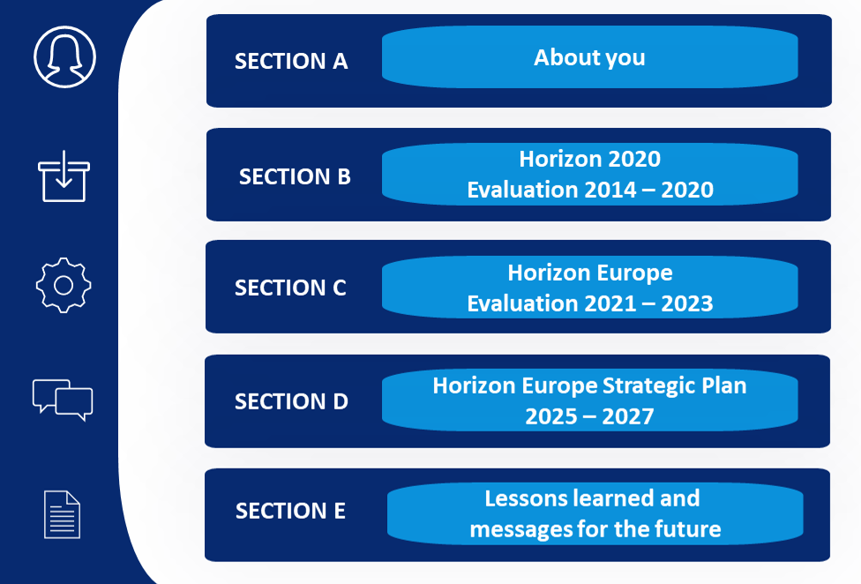

* ***Section A “About you”****asks information about the respondent’s profile.*
* ***Section B****focuses on the****past programme Horizon 2020****(2014 – 2020) and aims to collect feedback and evidence to****draw lessons from the past****. This part of the consultation will feed into the ex-post evaluation of Horizon 2020.*
* ***Section C****focuses on the****current programme Horizon Europe****(2021 – 2027) and aims to take stock of what stakeholders are currently experiencing to possibly****adapt current actions****. This part of the consultation will feed into the mid-term evaluation of Horizon Europe, covering the period 2021 – 2023.*
* ***Section D****collects views and opinions for the****upcoming Strategic Plan of Horizon Europe****(****2025 – 2027****). The questionnaire concerns the future societal challenges that should****shape future EU research and innovation****activities, the strengths and weaknesses of the European R&I system, EU Missions, European Partnerships and synergies with other EU programmes.*
* ***Section E****asks about the****key lessons learned and messages for the future****. If you wish so, you can****upload a position paper****in this section.*

*You can choose to****complete only one or more sections****of the consultation.  
  
You can****save your contribution as a draft****on the server and continue later or on a different day.*

*As the consultation looks at the****past, the present and the future of European Research Framework Programmes****, some topics are addressed under multiple sections.*

*For example, both section B (Horizon 2020) and section C (Horizon Europe) examine how the programmes contributed (or is contributing) to climate, health, digital and industrial transitions. Likewise, questions on the programme’s implementation and administrative procedures are asked in the two sections to account for the simplification measures introduced in Horizon Europe.*

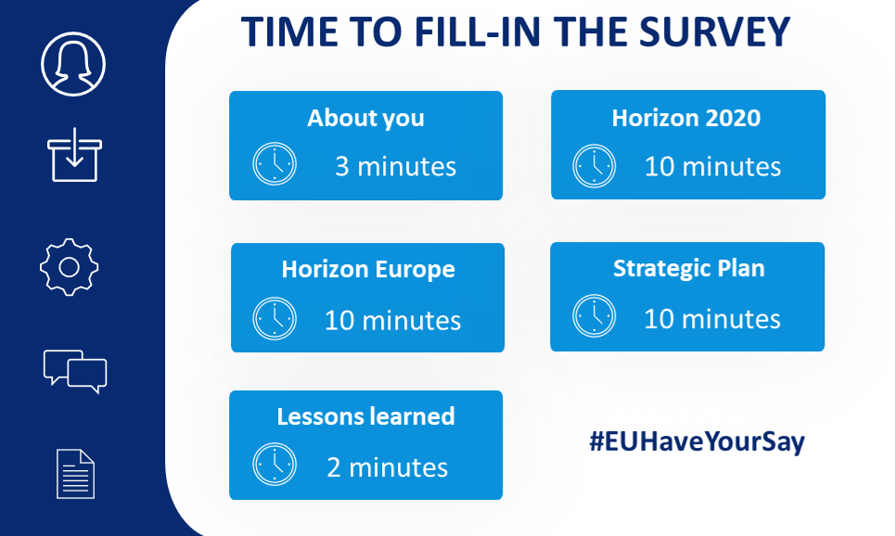

**OS animamos a que contribuyáis a este estudio y aportando vuestra visión, especialmente en el área relativa a Clúster 3 – Seguridad.**

* **Información semana DRS (Disaster-resilient societies) de CERIS (Community for European Research and Innovation for Security), 7 al 11 de noviembre.**

Ya están disponibles las presentaciones de dicha semana, así como la grabación de la misma. Toda la información disponible en el enlace siguiente: <https://www.cmine.eu/page/ceris-november22>

Así mismo, os recordamos que, a través del enlace siguiente: <https://home-affairs.ec.europa.eu/networks/ceris-community-european-research-and-innovation-security/ceris-events_en>, podéis manteneros informados sobre próximas jornadas y eventos organizados por CERIS y DG HOME.

Esperamos que esta información os resulte de interés. Un cordial saludo,

*Maite Boyero Egido*

*Representante y Punto de Contacto Nacional Clúster 3, Horizonte Europa*

*Departamento de Retos Sociales. Dirección de Programas Europeos y Cooperación Territorial*

*Centro para el Desarrollo Tecnológico Industrial, E.P.E.*

*C/Cid, 4. 28001 Madrid*

*maite.boyero@cdti.es**, +34 91 581 55 62*